Data – Useful information

Siva, Victor, Divya, Man, Marvin – information

Revature Batch4 associates names

1. Victor
2. Divya
3. Man Thakali
4. Marvin

How to Process Data??

First Store the Data – Creating / Writing the data

Where to store the data???

You can store the data in (flat) file. Text file (.txt), document (.doc/docx) , excel sheet (.xls/xlsx), rich text format (.rtf)

Challenges in storing the data in a flat file.

1. Hard to search & retrieve the data
2. The data is stored in un-structured format

Storing the data in a structured way, is called database.

Database generally stores the data in a structured format.

All the contents created inside the data base is called entity.

Database Entities

1. Table
2. Sequence
3. View
4. Query
5. Stored Procedure
6. Functions
7. Materialized Views
8. Triggers
9. Constraints

In Java, Everything is called as Object

In RDBMS, Everything is called as Entity

DBMS – Data Base Management System – It’s a software to manage the Database

RDBMS – Relational Data Base Management System

Relationship between two or more DB tables

You are going to buy a iPhone in amazon Big Billion Days.

1. Your personal info (Name, address, delivery address)
2. Billing info (Credit/Debit Card/ Internet Banking/ )
3. Shipment info (Name of Shipper/ Tracking Number, Tracking link)
4. Order Info (Order No, Date & Time of Order, Payment Mode)

In Database the primary place where the data gets stored in a proper/structured format is called Table.

Table is the main/primary entity in database.

Table contains rows and columns.

Each row contain various information about a particular person/object.

Each Column contains same information of many people/objects

Example/Sample Table:

**Associates**

|  |  |  |  |
| --- | --- | --- | --- |
| **ID** | **Name** | **Email** | **Phone** |
| 100 | ABC | [abc@gmail.com](mailto:abc@gmail.com) |  |
| 101 | XYZ | [xyz@gmail.com](mailto:xyz@gmail.com) |  |
| 102 | MNO | [mno@gmail.com](mailto:mno@gmail.com) |  |

In Database, we use a Language called SQL

SQL – Structured Query Language

This Language is used to do all operations in database.

Frequent Operation in Database.

In DB we do 4 operations normally. These are called CRUD operations

C – Create ( Creating a Table or Inserting a new row in the table)

R – Read ( Reading the content of the table)

U – Update ( Editing or Updating a particular row or column for all row)

D – Delete (Removing either a single row, column or multiple row )

SQL – It’s pronounced as “Sequel”

SQL Based Database

No-SQL Based Database – MongoDB (Document Based Database)

Adv of SQL

1. It can store and process any types of Data. Text based, image based, JSON based, xml based
2. Searching, updating & deleting the Data is easy

Drawback in SQL

1. Only pre-defined / pre-structured data only processed
2. It manages organized data only
3. Handling un-organized or dynamic data is difficult

Social Medias – No-SQL based Database

Facebook/ Twitter/LinkedIn

1. Text / character-based post
2. Image based Post
3. Audio/Video based post
4. Poll based post
5. Survey based Post
6. Adv Post

Datatypes used in Database

1. Numbers (int, float, double, bigint, decimal, long)
2. Text (varchar – variable character, varchar2, char)
3. Boolean
4. JSON

Database Manufactures/ Developers

1. Oracle
2. MySQL
3. MS-SQL (MicroSoft SQL) Server
4. DB2
5. Postgres (Open Source RDBMS )

Enterprise Edition & Community Edition (Open Source)

MySQL – Popular SQL based database

Ways of Accessing Database

1. Using Command Line Client [CUI mode] – Character User Interface
2. Using Graphical User Interface Client [GUI Mode] – MySQL Workbench, Dbeaver, PgAdmin, Web Interface for Oracle XE
3. Using any Programming Lang (Java, .Net, Php, Python etc.,)

DBMS & RDBMS is a client/server software.

Hotel – Server

1. Go and take the place
2. Server will provide us menu card
3. Based on the available choices, we will decide our food
4. Give the order to server
5. Server will pass the order to kitchen
6. Once the food is ready, server will bring the food to table
7. Eat it,
8. Pay bill
9. Exit from hotel

Client – Server uses a concept/model Request - Response

Client is web browser (server role of hotel) - will send a request to server

Server (Web/Application/DB) will check request and provide response if it is valid or provide error in case of invalid request.

Database also works as a Client -Server format

1. Database Server (This software can be running in the same machine where the client is sending request or in a remote machine)
2. Database Client [CUI based/GUI based client]

Accessing MySQL using command line client [CUI Mode]

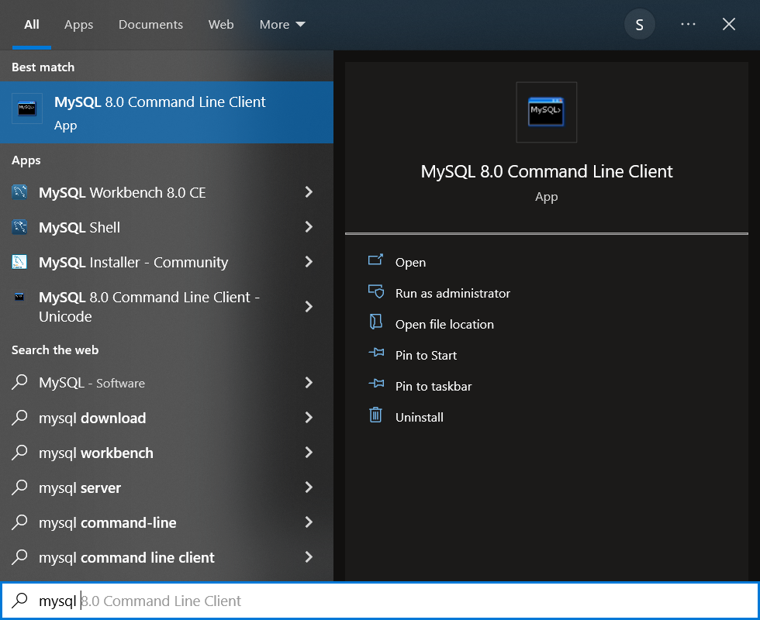

Enter the password which you have provided during installing MySQL server

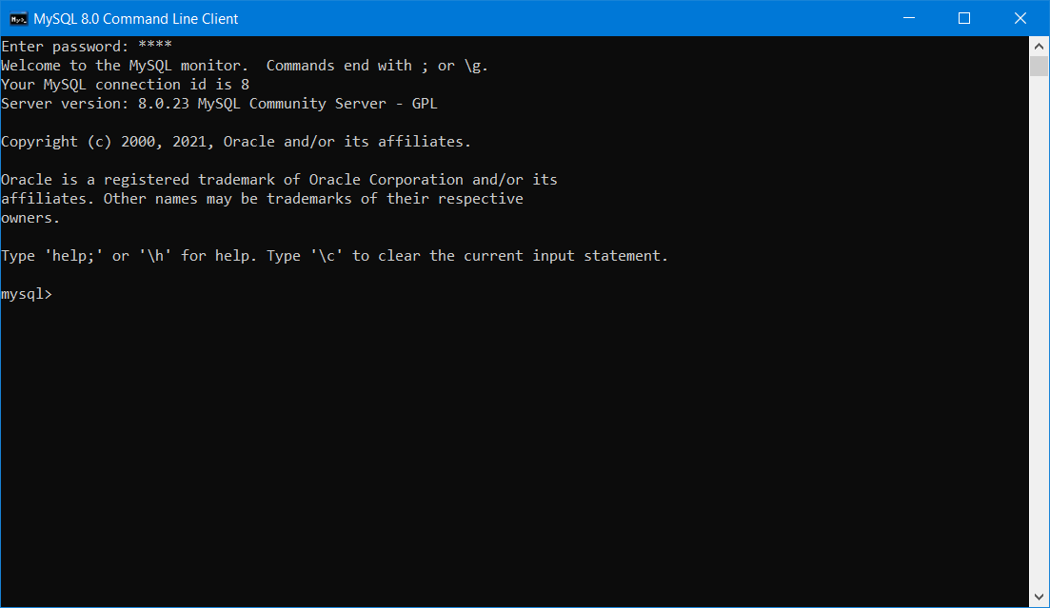

If the password is valid, you will get mysql> command prompt as shown above.

In this Mysql command prompt you can enter any sql based queries

To list all available databases

“Show databases;”

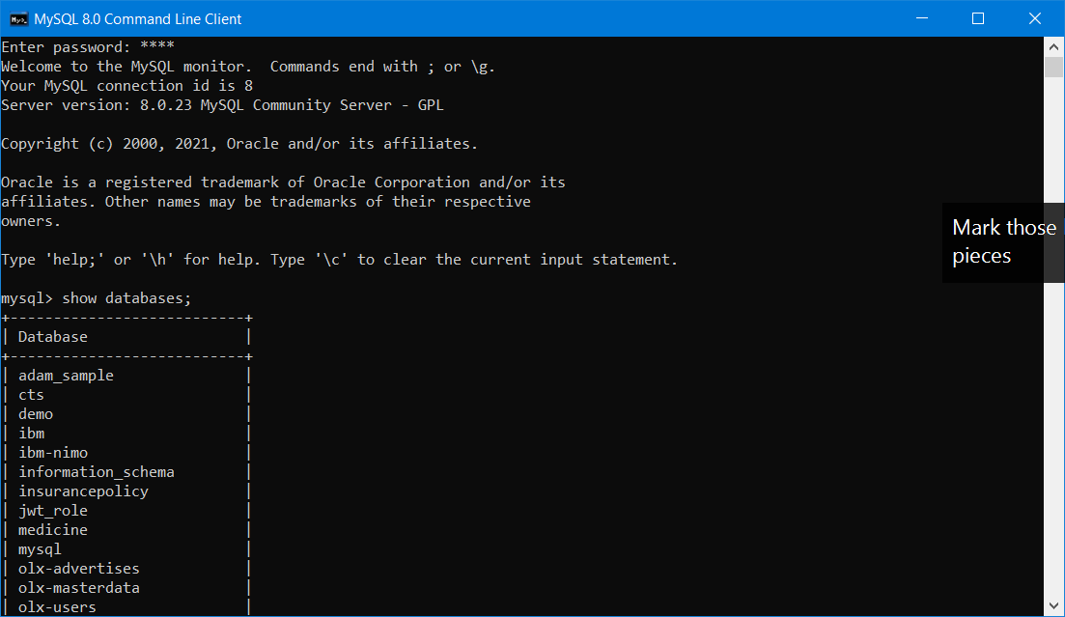

To Create a new database

“create schema rev_batch4;”

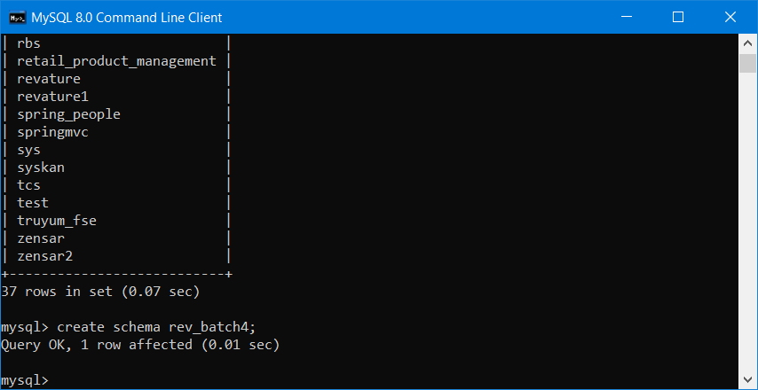

To select a particular database,

“use rev_batch4;”

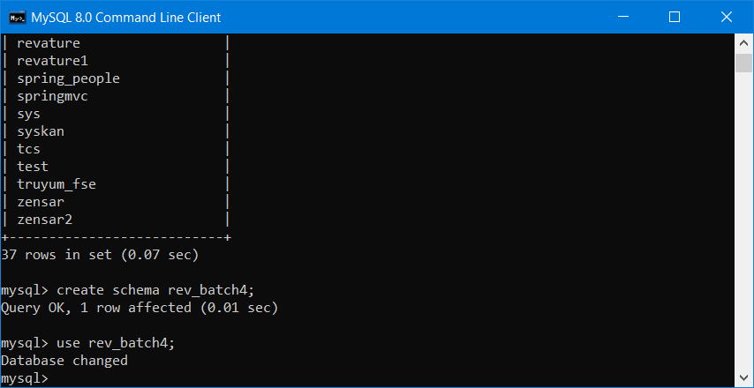

To list all the tables available in a particular database

“show tables;”

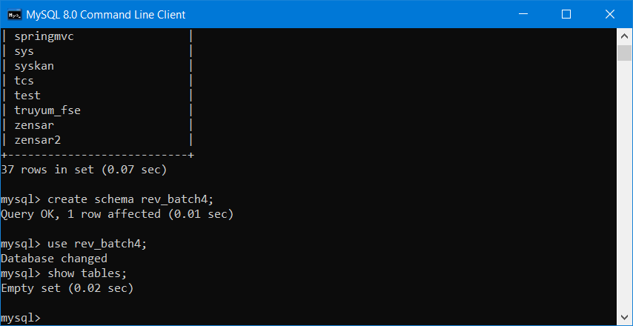

To Exit/Quit from MySql command line client

“quit/exit;”